Marwadi University
Faculty of Computer Applications

BCA 4E Python CSE Exam

Enrollment No. : 92400527321
Name :Neeraj kumar pandey
Class : BCA 4E
Date : 03/03/2026

Answer – 1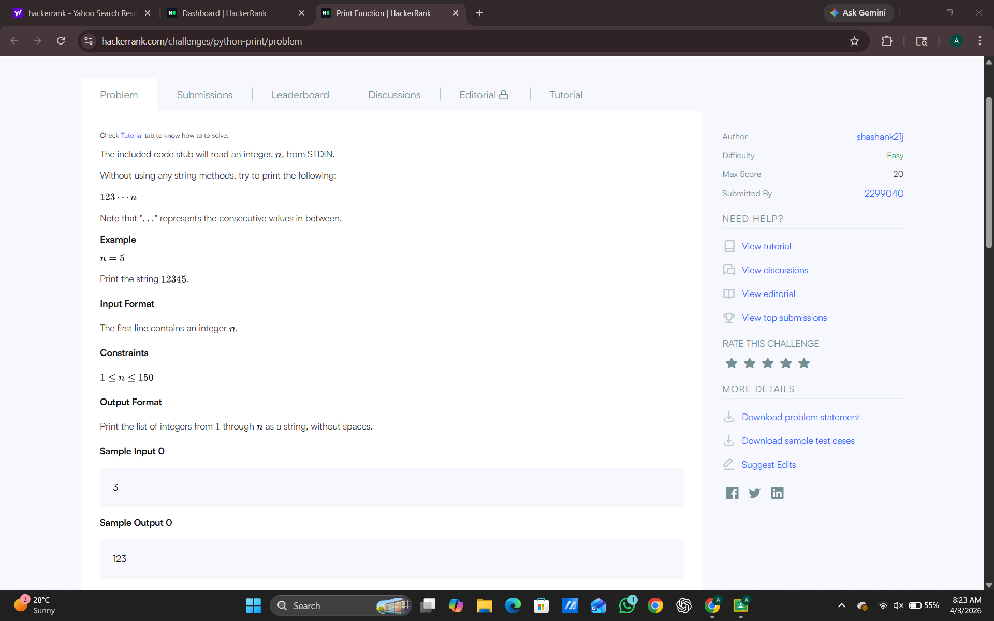

Answer – 2
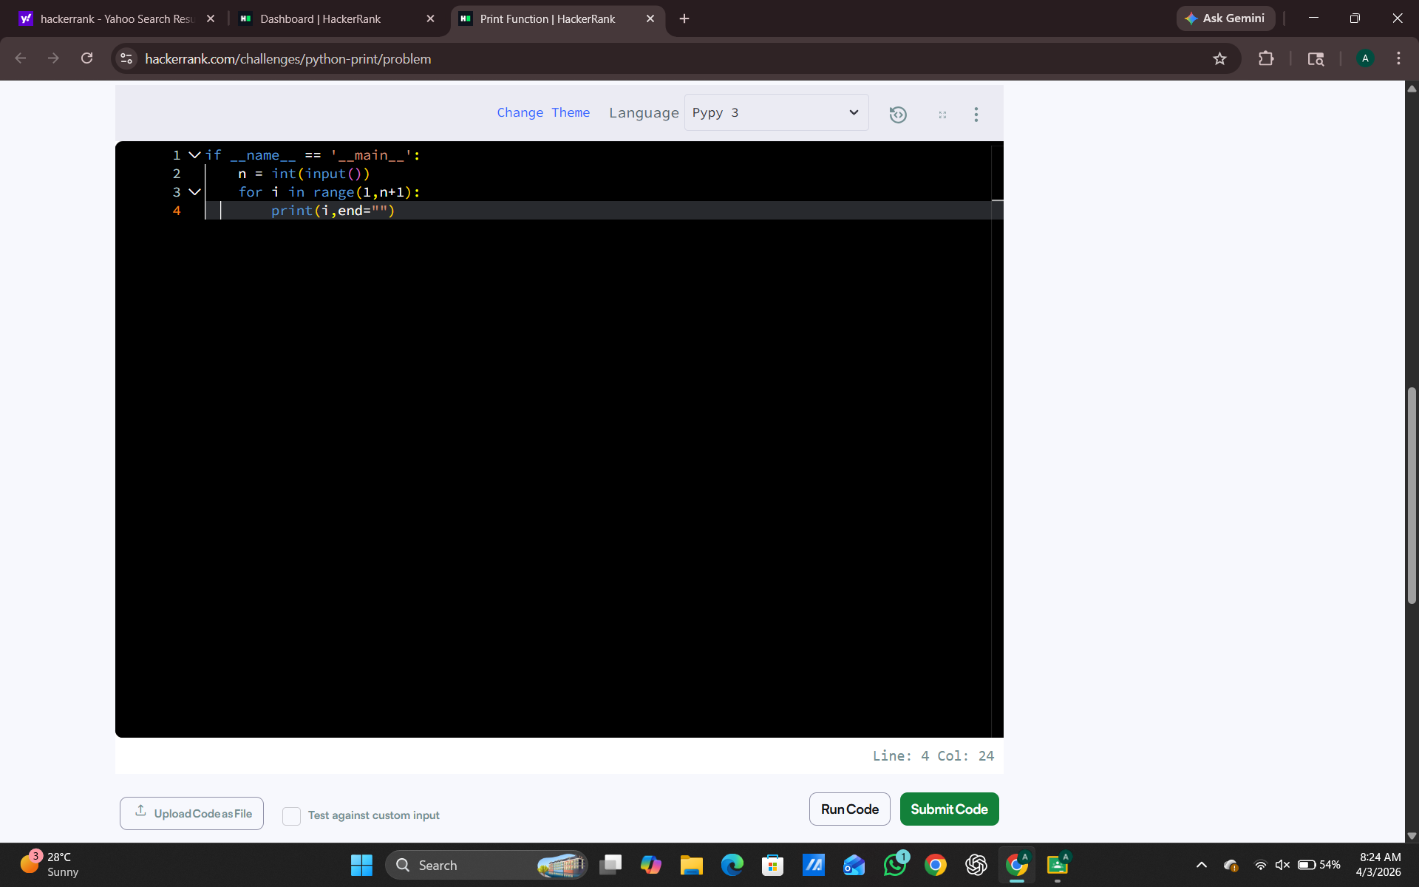
Answer – 3
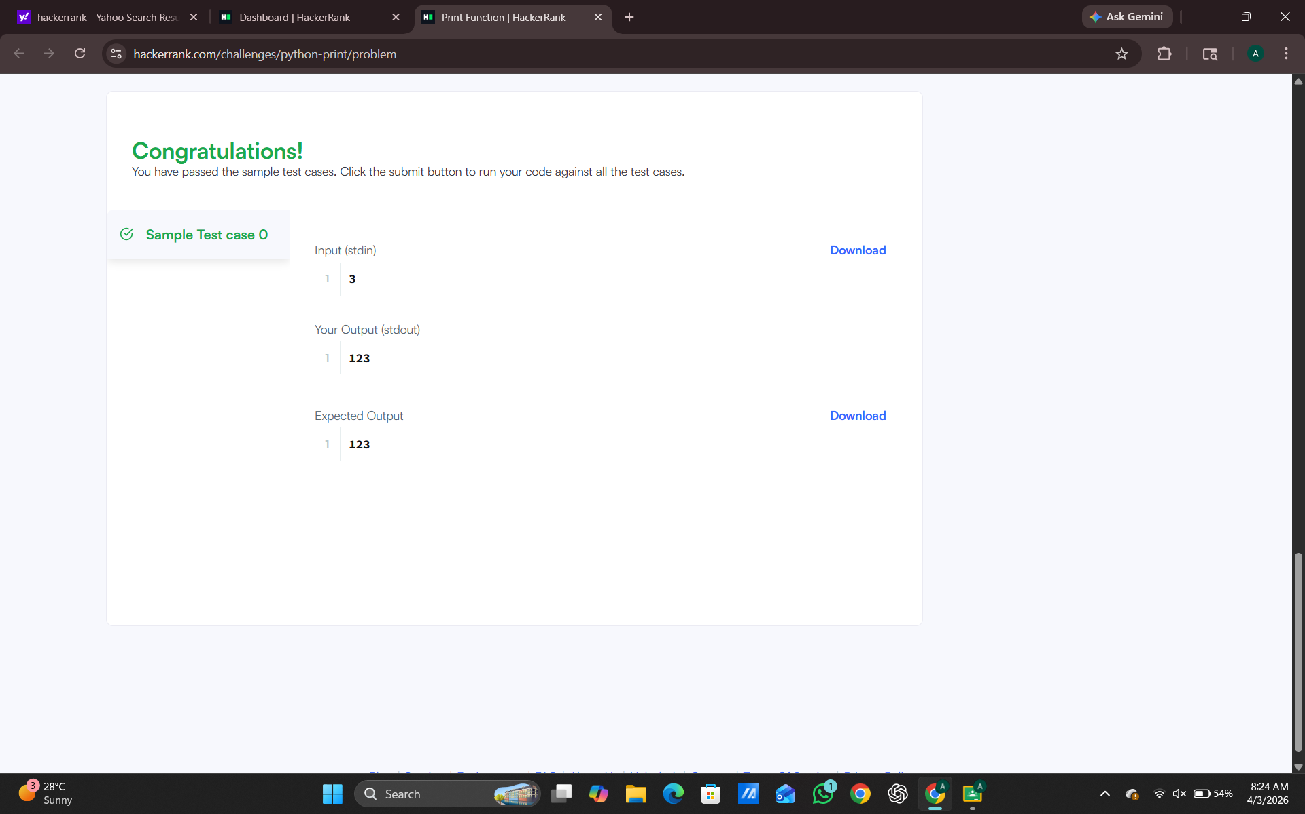
Answer – 4

Answer - 5

